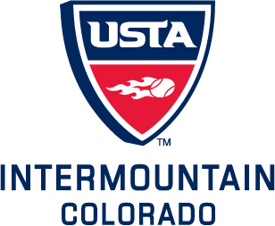

USTA COLORADO

SCHOOL TENNIS

2013-2014 Equipment Match Grant Application

As part of its mission to promote and develop the growth of tennis, USTA Colorado offers an Equipment Match grant to schools that qualify. This matching grant is intended to assist USTA School Tennis program participants who plan to conduct a Kids Tennis Club. To take advantage of this offer, please submit an application form with payment (check or purchase order) to the USTA Colorado office. Grants are reviewed on a first-come, first-served basis, with a maximum matching value of $100 per school.

*Your organization MUST be a USTA Organizational Member and
registered as a Kids Tennis Club to qualify for a Matching Grant*

ORDER FORM
Equipment | Unit Price | Quantity purchased by School | School Cost | Quantity matched by  USTA CO | USTA CO Cost  (limit $100 total) | Total Order Quantity  (including  USTA CO match)
18' Lightweight Net | $100.00
Racquet 21” | $10.00
Racquet 23” | $10.00
Racquet 25” | $10.00
Racquet 27” | $12.00
Foam Transition Balls (1 dozen) | $20.00
Low Compression Balls(1 dozen) | $10.00
TOTAL

Method of Payment: Check Purchase Order
(Please make payable to USTA Colorado)

TOTAL SCHOOL COST
SHIPPING 15% of (total school cost + total USTA CO cost) +
TOTAL AMOUNT ENCLOSED: =

************************* OVER - PLEASE COMPLETE PROGRAM INFORMATION ******************
Shipping Address:

School Name:
Contact Name:
Shipping Address (no PO Boxes):
City, State, Zip:
Phone:
Email:
USTA Organizational Membership Number:
(To become a USTA Organizational Member you can call 1-800-990-8782 or visit www.usta.com/orgmember)
Please outline your Extracurricular Tennis Program/Kids Tennis Club:

Location:

Conducted by:

Approximate dates:

Targeted age group: Estimated number of participants:

Basic plan:

Have you registered your Kids Tennis Club at www.usta.com/kidstennisclubs? Yes No (Contact us if you need assistance)

What other resources from USTA/Colorado would be helpful?

Return to:
USTA Colorado
Attn: Community Development
3300 East Bayaud Ave., Suite 201
Denver, CO 80209
Fax. (303) 695-7631
Tel. (303) 695-4116 x300
Email. kristy@coloradotennis.com
Updated Aug 2013

